GitHub Link = <https://github.com/GenericUser2025/csd-340>

// Paul Singleton > CSD340_Module 3.2 > August 25, 2024

**HTML Validator Results - Deliverable 1:**

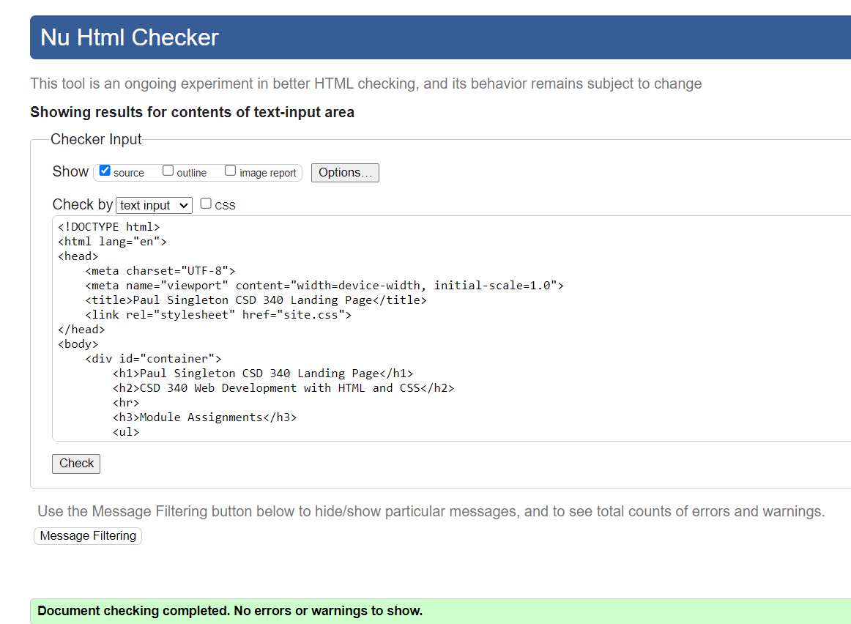

**CSS Validator Results - Deliverable 2: (Attached below…)**

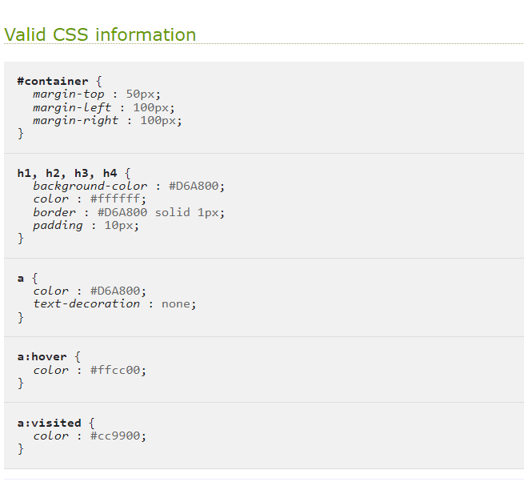

**Website Landing Page in Chrome - Deliverable 3:**

